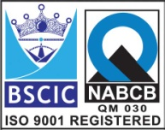****

**“EASCO” Swing Check Valve Flanged ASA150#**

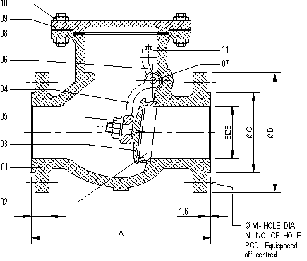**Technical Data-**

* Manufacturing Std: BS 1868
* Testing & Inspection Std: API 598 / BS 5146
* Face to Face Std: As Per ANSI B 16.10
* End Connection: Flanged ANSI B16.5 RF

**Testing Standard: - API 598 / BS 5146**

|  |  |  |
| --- | --- | --- |
| Test Pressure in PSIG | | |
| Test | Hydrostatic | Air |
| Pr. Rating | ASA150# |
| Body | 425 PSIG |  |
| Seat | 300 PSIG | - |

**Temp: 500’ F**

**Part Name:- Design Std:-**

|  |  |  |  |  |  |  |  |  |  |  |  |
| --- | --- | --- | --- | --- | --- | --- | --- | --- | --- | --- | --- |
| **No.** | **Part Name** | **Material** |  | **Size** | **A** | **B** | **C** | **D** | **M** | **N** | **PCD** |
| **01** | **Body** | **ASTM A351 Gr. CF8** |  | **40** | **165** | **14** | **73** | **127** | **15** | **4** | **98** |
| **02** | **Seat Ring** | **ASTM A351 Gr. CF8** |  | **50** | **203** | **16** | **92** | **152** | **19** | **4** | **121** |
| **03** | **Disc** | **ASTM A351 Gr. CF8** |  | **65** | **216** | **18** | **105** | **178** | **19** | **4** | **140** |
| **04** | **Hinge** | **ASTM A351 Gr. CF8** |  | **80** | **241** | **19** | **127** | **190** | **19** | **4** | **152** |
| **05** | **Disc Nut** | **ASTM A276-T304** |  | **100** | **292** | **24** | **157** | **229** | **19** | **8** | **190** |
| **06** | **Bracket** | **ASTM A351 Gr. CF8** |  | **150** | **406** | **25** | **216** | **279** | **22** | **8** | **241** |
| **07** | **Hinge Pin** | **ASTM A276-T304** |  | **200** | **495** | **29** | **270** | **343** | **22** | **8** | **298** |
| **08** | **Gasket** | **PTFE** |  | **250** | **622** | **30** | **324** | **406** | **25** | **12** | **362** |
| **09** | **Cover** | **ASTM A351 Gr. CF8** |  | **300** | **699** | **32** | **381** | **483** | **25** | **12** | **432** |
| **10** | **Cover Stud & Nut** | **SS304** |  | **350** | **787** | **35** | **413** | **533** | **28** | **12** | **476** |
| **11** | **Bracket Stud /Nut** | **ASTM A276-T304** |  | **400** | **863** | **37** | **470** | **597** | **28** | **16** | **540** |

**Due to continuous development Program, the design & data given in this leaflet are subject to change without prior notice.**

**ANITA ENGINEERING WORKS**



58-59, Narayan Estate, Opp. Shree Ram Estate, Nr. CMC Ltd. Odhav, Ahmedabad-382415, Gujarat, India

Phone: +91 79 22974101, Fax: +91 79 22875014

Email: eascovalves@gmail.com, eascovalves@yahoo.com, Web: [www.eascovalve.com](http://www.eascovalve.com)